How To Design A Winning Customer Avatar In Less Than 15 Minutes
Reading Minds For Fun & Profit

Nicolas Cole
and
Dickie Bush
Jan 31, 2025
∙ Paid



Jim Hamilton is back.
And he’s here to share his Avatar Design Flow to help you design a winning customer avatar in less than 15 minutes.
In 5 prompts, you’ll define your ideal customer’s:
- Demographics: Who they are
- Psychographics: What they believe and value
- Unwanted Solutions: What they’ve already tried (and rejected)
- Identity Shifts: How they see themselves before and after
- Day-to-Day Life: What a typical day looks like
Plus, you’ll get a clear, concise avatar summary to use in all your future AI chats.
If you want to attract the right customers and speak directly to their needs, these audience insight prompts will make sure you’re never guessing who you’re writing for.
In case you don’t know, Jim is a copywriting expert who's written emails for Cole Gordon, Travis Chappell, Justin Moore, and many more in the online space over the last 8 years.
And if you missed his first couple posts, you can find them here:
- How to write a story-driven emails that sells
- How to use storytelling to uninstall your customer’s false beliefs
Here's Jim:

True story:
The better you know the person you’re writing to, the more sales you’ll make.
Only problem is, doing market research sucks.
Who wants to pore over angry Amazon reviews and pointless Reddit threads all day long?
Not me.
But back in the days before ChatGPT, that’s exactly what you’d have to do:
Spend hours and hours researching your customer avatar to try and understand how they feel, what they think, and the specific words & phrases they use to describe their problems.
Plus there was no guarantee you’d even find the gold nuggets you were looking for.
Luckily, those days are long gone.
Now you can design a winning customer avatar in less than 15 minutes…
That you can use to write laser-targeted content & copy that converts like crazy.
And I’m about to show you how.
Let’s dive in.
What You’ll Need to Complete This Avatar Design Flow
I’ve found ChatGPT delivers the best results.
So we’re going to use ChatGPT-o1 to complete this exercise.
But you can get decent results with ChatGPT-4o too.
On top of that, you’ll need to fill in a few placeholders.
These don’t need to be super in-depth. In fact, I’ve found sometimes that adding more info makes the outputs worse.
Here’s what I wrote for mine:
1) My Offer
The Email Storyselling Playbook - a 66-page book revealing the 4-step formula to convert subscribers into buyers even if you're not a natural writer or storyteller
2) My Customer
Coach, consultant, or online expert
3) Their Problem
Monetizing their newsletter or email list
That’s it.
Start with something similar and complete the exercise. You always circle back later and flesh out the description if you aren’t happy with the results.
📍SIDE NOTE: Once you've got your customer avatar dialed in, the next step is turning those insights into stories that sell. I break down the entire step-by-step process in my book.
Now let’s dive into the first prompt:
Prompt 1: Demographics & Psychographics
Here’s the full prompt:
Today, you're a world-class marketing analyst with an expertise in researching customer avatars.

I want you to create a customer avatar for [OFFER]. The typical customer is [DESCRIBE CUSTOMER]. Many struggle with [PROBLEM].

Include Demographics, Psychographics, Values, and at least 5 examples of Pains (how their problems manifest in the present), Fears (how their problems manifest in the future), Frustrations, Desires, False Beliefs, Trigger Moments (events in day-to-day life that bring their pains to the forefront) and Painful Questions (questions they ask themselves, but would never say out loud or admit to anyone else), as well as their Core Problem (the root problem causing all of their other symptoms) and their Ultimate Desire (their vision of the future where all their problems have been solved). Give the Core Problem and Ultimate Desire a unique name.

Be as specific, detailed, and emotional as possible. Give the avatar a real name so it's easy for us to refer to going forward.
Now, be warned:
This one prompt spits out a TON of useful intel about your customer avatar.
It’s more than most entrepreneurs know about their audience even if they’ve been in business for years.
Here’s everything I got back:

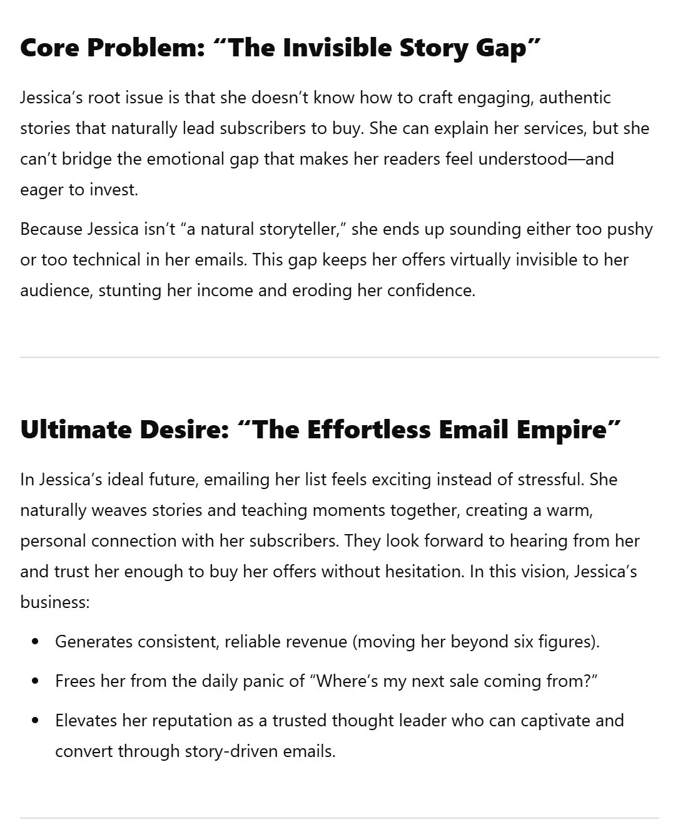

I recommend regenerating this first answer 2-3 times and choosing the one you like best before moving on.
In my case, this is right on the money.
Before go any further, here’s how to conceptualize and implement some of this intel:
- Demographics: These paint a clearer picture of what our avatar’s life looks like on the surface. Can be helpful for ad targeting, depending on the platform.
- Psychographics: These map the hidden terrain of our avatar’s mind. What’s going on inside their head and driving their day-to-day activities in life and business.
- Values: These reflect what attracts our avatar beyond her #1 goal, which in this case is money. We’ll infuse our ads, emails, and content with these values to dial up their persuasive power even more.
- Pains: This is what our avatar’s struggling with right now. Calling them out in hooks, headlines, subject lines, and leads is how we’ll shift her into a “problem state of mind.”
- Fears: If left unsolved, this is how her Pains will manifest in the future. We’ll use them to create urgency and illustrate the cost of doing nothing.
- Frustrations: This emotion has a strong buying resonance. Frustration implies they’re trying to solve the problem, but not being successful. These also make for great hooks.
- Desires: We all crave the things we don’t have. Appealing to these is how you’ll paint a picture of the future that motivates them to take action.
- False Beliefs: These are misconceptions about the method, the offer, or themselves that prevent our avatar from moving forward. We’ll need to uninstall them towards the end of our sales argument - especially before presenting a high-ticket offer. More on how to do that here.
- Trigger Moments: These are day-to-day events that bring problems to the forefront. The highest-converting stories always revolve around a trigger moment.
- Painful Questions: This is what the little devil on our avatar’s shoulder is whispering into her ear every time she fails. Weaving these questions into any stories we tell will twist the knife even further.
- Core Problem: Most people focus on symptoms and ignore the root cause. By revealing the true source of all our avatar’s problems, we can take a diagnostic frame and differentiate ourselves from the competition.
- Ultimate Desire: This is a snapshot of what life will look like once all our avatar’s problems have been solved. If we can position our offer as the only way to get here, we’ve won the sale.
Okay, now let’s move on.
Prompt 2: Unwanted Solutions
Positioning hack:
Polarizing yourself against unwanted solutions.
You see, there’s more than one way to solve any problem… whether it’s getting matches on Tinder, carving out six-pack abs, or hitting $10,000 per month. And, chances are, your audience is already aware of (or has tried) other ways to solve this problem that don’t work.
So this next prompt reveals what these unwanted solutions are…
And more importantly: what they dislike about them.
Here’s the full prompt:
Great! Now what are some other solutions [NAME] has likely tried in the past to solve their problems? List out what they dislike about each solution, and phrase them as quotes directly from [NAME]. Remember to be as specific, detailed, and emotional as possible.
Here’s what I got back:

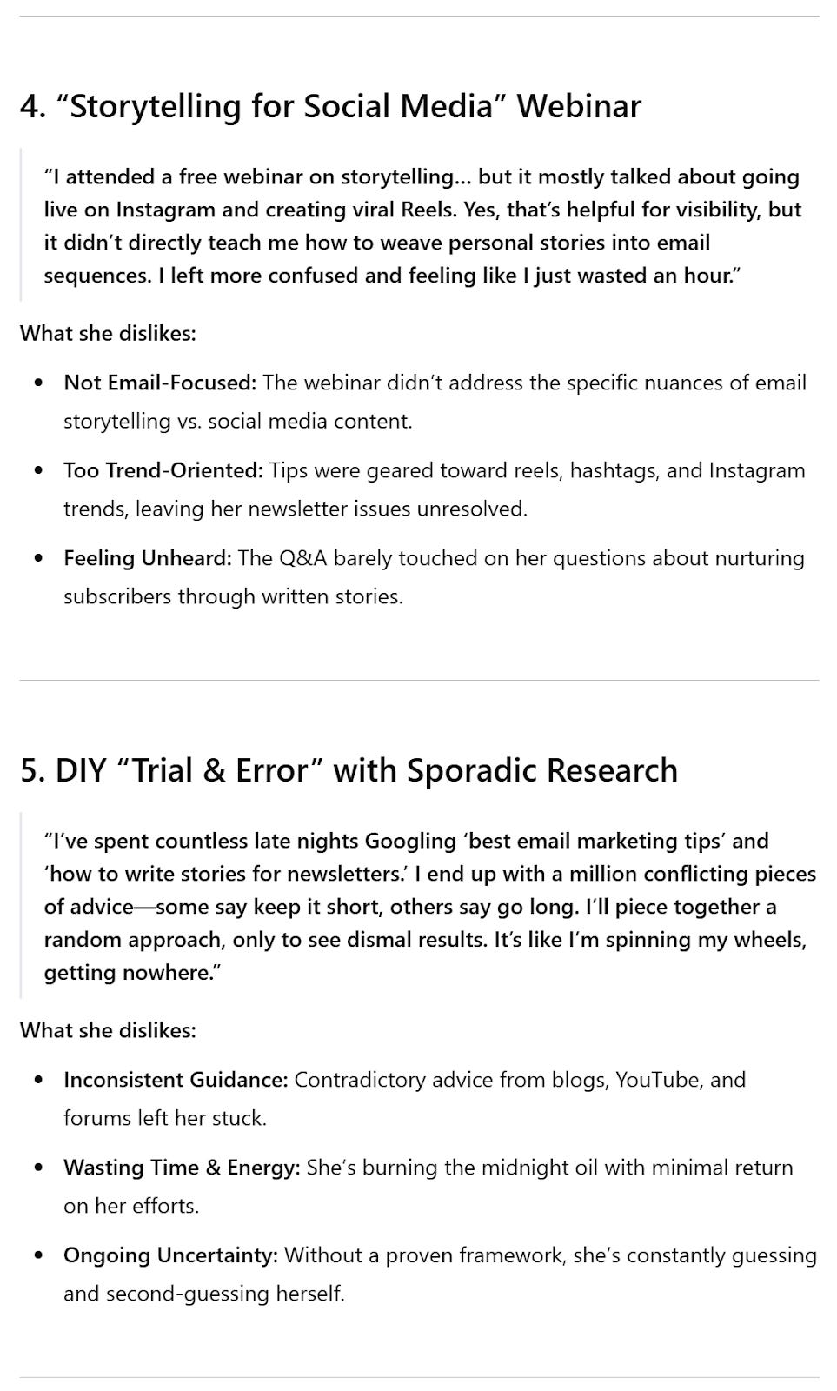

How to use these in your content & copy:
Frame them with the word ‘without’.
For example, if I was writing a headline to this avatar, I might say:
Learn How to Write Story-Driven Emails That Sell Without Fill-in-the-Blank Templates,
Hiring a Copywriter, or Relying on Trial & Error
See how that works?
Let’s move on.
Prompt 3: Identity Shift
Every product or service ultimately leads to transformation.
And getting clear on the identity shift you’ll provide to your avatar helps clarify your messaging.
Here’s the full prompt:
Great! How would [NAME]'s identity change if my offer finally solved their problems once and for all? Break this into two categories and list out at least 10 ways for each one: How [NAME] would perceive themselves differently, and how other people around [NAME] would perceive them differently.
Here’s what I got back:

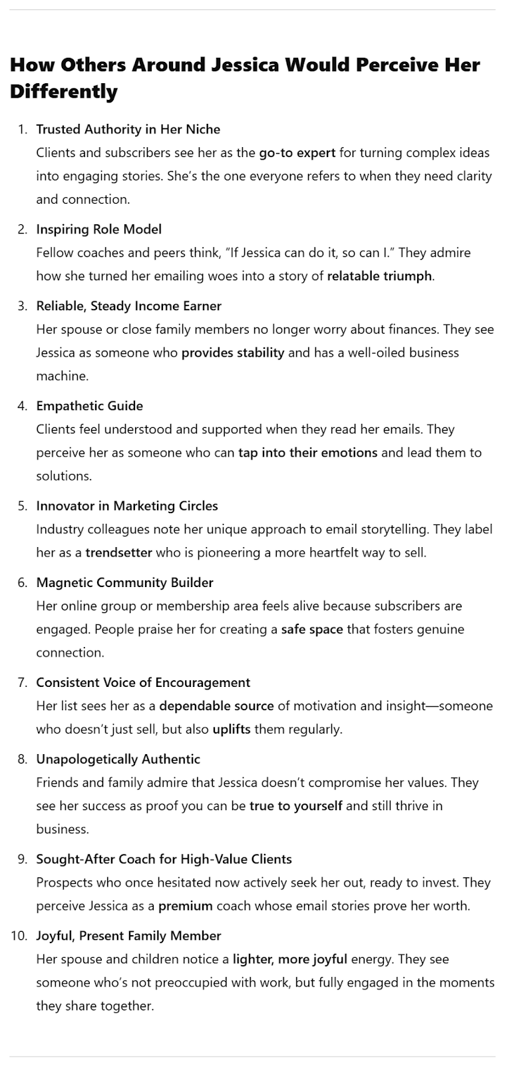

One way to illustrate this identity shift:
“Go From [OLD IDENTITY] to [NEW IDENTITY]”
For example:
- Go From Unknown Expert to Trusted Authority
- Go From Struggling Coach to Confident Storyteller
- Go From Wannabe Entrepreneur to Purpose-Driven Business Owner
Got it?
On to the next…
Prompt 4A: Day-to-Day Life
They say if you want to understand someone, you should walk a mile in their shoes.
We may not be able to do that…
But the next best thing is knowing what a “day in the life” is really like.
That’s where this next prompt comes in.
We’ll contrast our avatar’s day-to-day life before and after our solution in two parts.
Here’s the first part:
Great! How would [NAME]'s day-to-day life change once they finally solved their problems? Give me an hour-by-hour breakdown and compare Before and After. Be as specific, detailed, and emotional as possible when it comes to their activities and what they’re thinking and feeling while doing them.
Here’s what I got back:

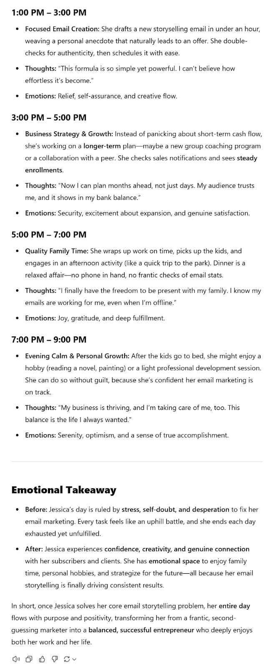

See how vividly this illustrates what a “day in the life” is like for them?
This makes it so much easier to write relatable content & copy that makes the avatar feel like you really understand them.
We’re almost done.
Prompt 4B: Day-to-Day Life
Lastly, we’ll look at their daily life through the lens of pleasant vs unpleasant activities.
Here’s the next prompt:
Perfect. Sticking with this Before vs After comparison of how their day-to-day life will change, please list out 10 unpleasant activities [NAME] will no longer have to do and 10 new and pleasant activities [NAME] will be able to do once they finally solve all their problems, as well as how each one of those activities makes them feel. Format it in a table so I can compare them side-by-side.
Here’s what I got back:

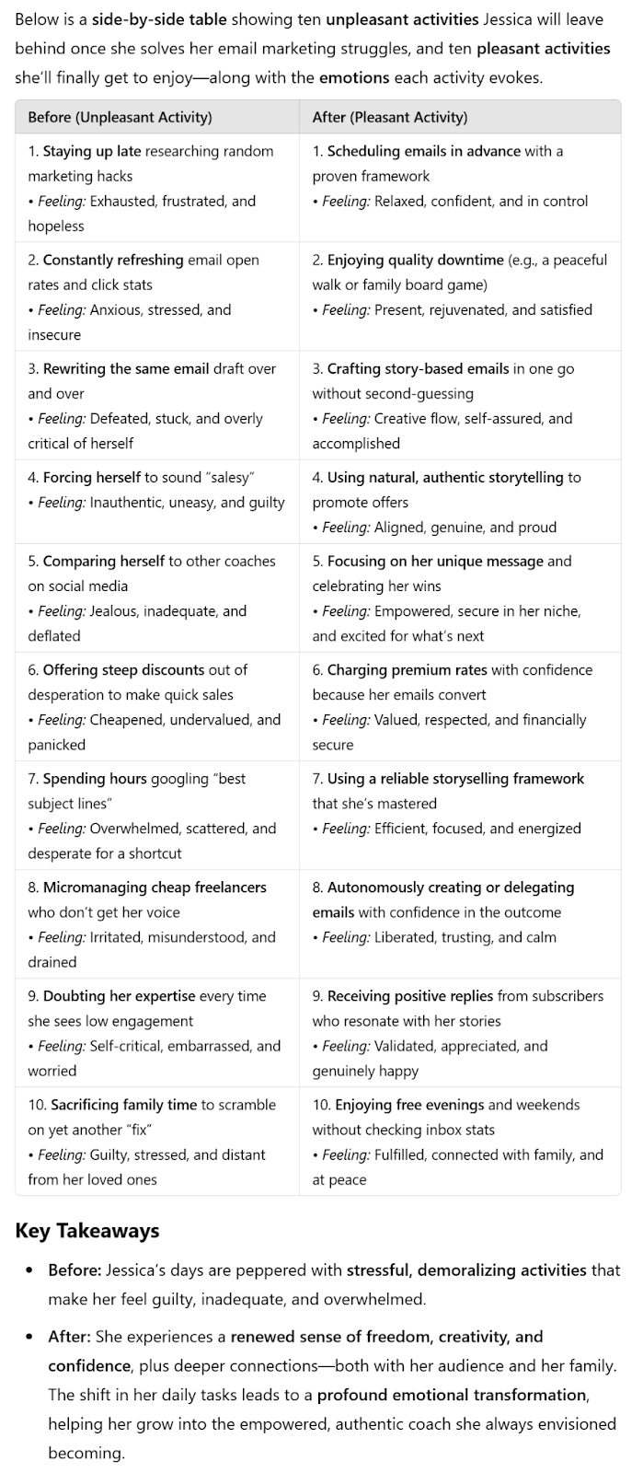

Here’s how to deploy these insights in your content & copy:
Use ‘without’ to frame unpleasant activities:
- Write Winning Emails Without Sounding ‘Salesy’
- Monetize Your Newsletter Without Sacrificing Family Time
- Get Daily Sales From Your List Without Discounting Your Offers
Use ‘imagine’ to frame pleasant activities:
- Imagine finally getting your evenings and weekends back…
- Imagine having a reliable step-by-step framework to write emails that sell…
- Imagine charging premium rates and getting to cherry-pick the best clients to work with…
Pure gold.
Prompt 5: Portable Summary
From here, I like to copy-paste all the outputs from these chats into a separate document for easy reference.
But what if you want to use this info in other chats?
Or with other chatbots?
No problemo.
Just use the following prompt to extract a short and detailed summary you can carry forward into other AI chats.
Here it is:
Beautiful! Now write me a short yet detailed summary of everything you’ve learned about this customer avatar so I can give you all the necessary context in other conversations to write high-converting content & copy to people like [NAME].

Keep the summary short enough I can paste into a single prompt, but make it as long as it needs to be. Do not repeat everything you’ve already said in this conversation. Focus only on the most important details.
Here’s what I got back:

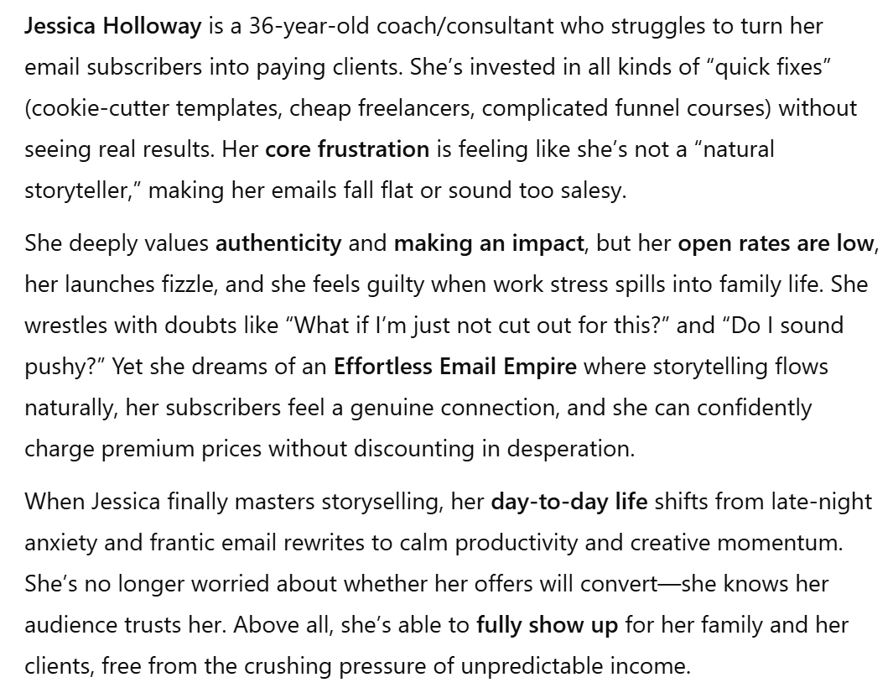

Now you’ve got a portable summary of this customer avatar you can use to quickly spin up new assets in other conversations and with other chatbots.

